**WEEK 5: MICROSERVICES**

* **2. Microservices with API gateway**
* **Creating Microservices for account and loan**

**Account Microservice**

**Codes:**

**AccountApplication.java**

package com.cognizant.account;

import org.springframework.boot.SpringApplication;

import org.springframework.boot.autoconfigure.SpringBootApplication;

@SpringBootApplication

public class AccountApplication {

public static void main(String[] args) {

SpringApplication.run(AccountApplication.class, args);

}

}

**AccountController.java**

package com.cognizant.account.controller;

import org.springframework.web.bind.annotation.*;

import java.util.Map;

@RestController

@RequestMapping("/accounts")

public class AccountController {

@GetMapping("/{number}")

public Map<String, Object> getAccountDetails(@PathVariable String number) {

return Map.of(

"number", number,

"type", "savings",

"balance", 234343

);

}

}

**pom.xml**

<project xmlns="http://maven.apache.org/POM/4.0.0"

xmlns:xsi="http://www.w3.org/2001/XMLSchema-instance"

xsi:schemaLocation="http://maven.apache.org/POM/4.0.0

http://maven.apache.org/xsd/maven-4.0.0.xsd">

<modelVersion>4.0.0</modelVersion>

<groupId>com.cognizant</groupId>

<artifactId>account</artifactId>

<version>0.0.1-SNAPSHOT</version>

<packaging>jar</packaging>

<name>account</name>

<description>Account Microservice</description>

<parent>

<groupId>org.springframework.boot</groupId>

<artifactId>spring-boot-starter-parent</artifactId>

<version>3.2.4</version> <!-- Use the latest version if needed -->

<relativePath/>

</parent>

<properties>

<java.version>17</java.version>

</properties>

<dependencies>

<dependency>

<groupId>org.springframework.boot</groupId>

<artifactId>spring-boot-starter-web</artifactId>

</dependency>

<dependency>

<groupId>org.springframework.boot</groupId>

<artifactId>spring-boot-devtools</artifactId>

<scope>runtime</scope>

</dependency>

<dependency>

<groupId>org.springframework.boot</groupId>

<artifactId>spring-boot-starter-test</artifactId>

<scope>test</scope>

</dependency>

</dependencies>

<build>

<plugins>

<plugin>

<groupId>org.springframework.boot</groupId>

<artifactId>spring-boot-maven-plugin</artifactId>

<version>3.2.4</version>

</plugin>

</plugins>

</build>

</project>

**application.properties**

server.port=8080

**Output:**

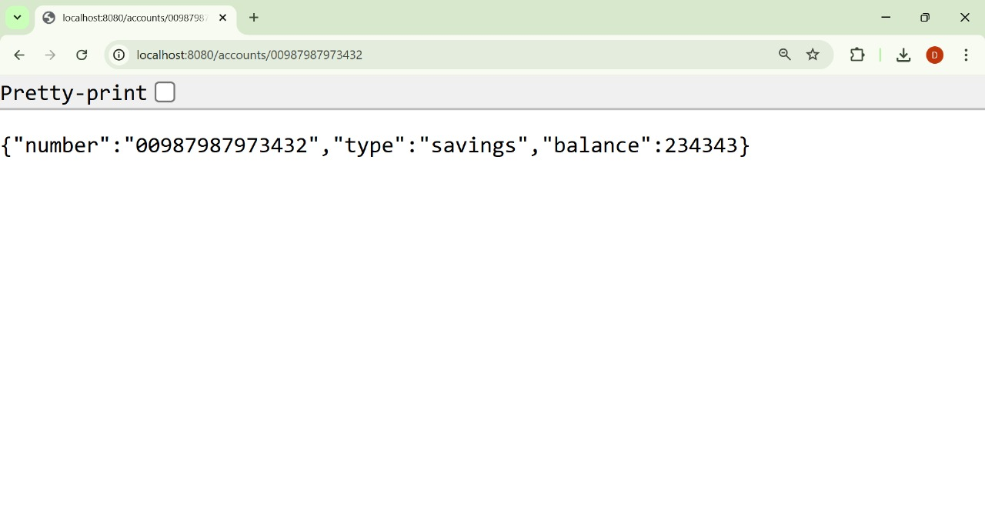

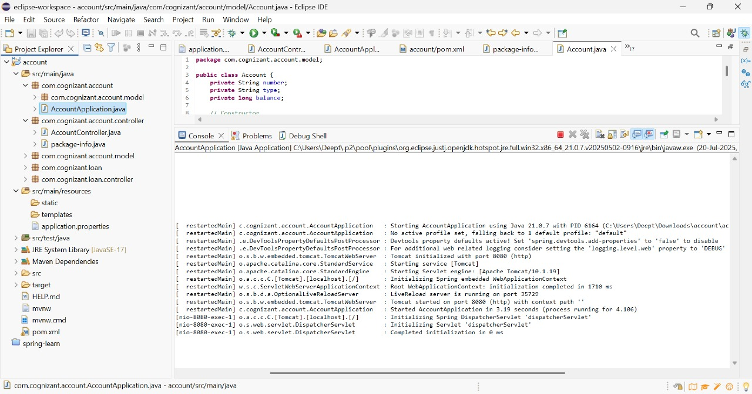

**Loan Microservice**

**Codes:**

**LoanApplication.java**

package com.cognizant.loan;

import org.springframework.boot.SpringApplication;

import org.springframework.boot.autoconfigure.SpringBootApplication;

@SpringBootApplication

public class LoanApplication {

public static void main(String[] args) {

SpringApplication.run(LoanApplication.class, args);

}

}

**LoanController.java**

package com.cognizant.loan.controller;

import org.springframework.web.bind.annotation.*;

import java.util.Map;

@RestController

@RequestMapping("/loans")

public class LoanController {

@GetMapping("/{number}")

public Map<String, Object> getLoanDetails(@PathVariable String number) {

return Map.of(

"number", number,

"type", "car",

"loan", 400000,

"emi", 3258,

"tenure", 18

);

}

}

**application.properties**

server.port=8081

**pom.xml**

<project xmlns="http://maven.apache.org/POM/4.0.0"

xmlns:xsi="http://www.w3.org/2001/XMLSchema-instance"

xsi:schemaLocation="http://maven.apache.org/POM/4.0.0

http://maven.apache.org/xsd/maven-4.0.0.xsd">

<modelVersion>4.0.0</modelVersion>

<groupId>com.cognizant</groupId>

<artifactId>loan</artifactId>

<version>0.0.1-SNAPSHOT</version>

<packaging>jar</packaging>

<name>loan</name>

<description>Loan Microservice</description>

<parent>

<groupId>org.springframework.boot</groupId>

<artifactId>spring-boot-starter-parent</artifactId>

<version>3.2.4</version>

<relativePath/>

</parent>

<properties>

<java.version>17</java.version>

</properties>

<dependencies>

<dependency>

<groupId>org.springframework.boot</groupId>

<artifactId>spring-boot-starter-web</artifactId>

</dependency>

<dependency>

<groupId>org.springframework.boot</groupId>

<artifactId>spring-boot-devtools</artifactId>

<scope>runtime</scope>

</dependency>

<dependency>

<groupId>org.springframework.boot</groupId>

<artifactId>spring-boot-starter-test</artifactId>

<scope>test</scope>

</dependency>

</dependencies>

<build>

<plugins>

<plugin>

<groupId>org.springframework.boot</groupId>

<artifactId>spring-boot-maven-plugin</artifactId>

<version>3.2.4</version>

</plugin>

</plugins>

</build>

</project>

**Output:**

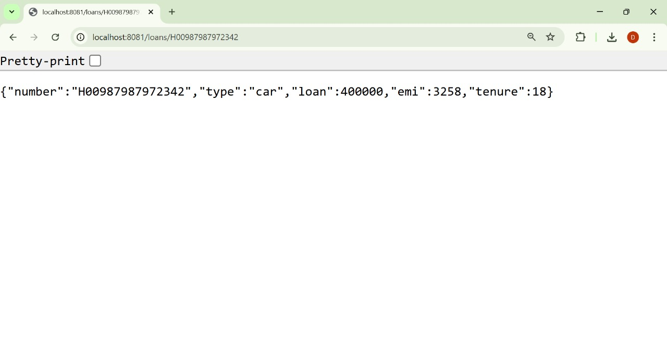

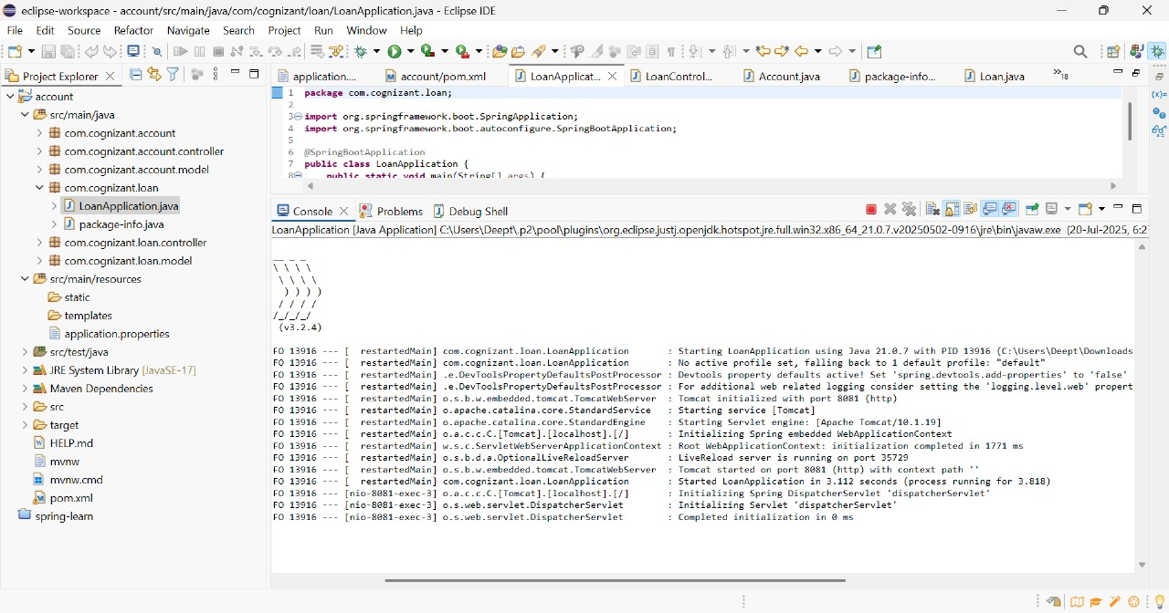

* **Create Eureka Discovery Server and register microservices**

**EUREKA DISCOVERY SERVER**

**Codes:**

**EurekaDiscoveryServerApplication.java**

package com.cognizant.eureka;

import org.springframework.boot.SpringApplication;

import org.springframework.boot.autoconfigure.SpringBootApplication;

import org.springframework.cloud.netflix.eureka.server.EnableEurekaServer;

@SpringBootApplication

@EnableEurekaServer

public class EurekaDiscoveryServerApplication {

public static void main(String[] args) {

SpringApplication.run(EurekaDiscoveryServerApplication.class, args);

}

}

**application.properties**

server.port=8761

eureka.client.register-with-eureka=false

eureka.client.fetch-registry=false

logging.level.com.netflix.eureka=OFF

logging.level.com.netflix.discovery=OFF

**pom.xml**

<project xmlns="http://maven.apache.org/POM/4.0.0"

xmlns:xsi="http://www.w3.org/2001/XMLSchema-instance"

xsi:schemaLocation="http://maven.apache.org/POM/4.0.0

http://maven.apache.org/xsd/maven-4.0.0.xsd">

<modelVersion>4.0.0</modelVersion>

<groupId>com.cognizant</groupId>

<artifactId>eureka-discovery-server</artifactId>

<version>0.0.1-SNAPSHOT</version>

<name>eureka-discovery-server</name>

<description>Eureka Discovery Server</description>

<packaging>jar</packaging>

<parent>

<groupId>org.springframework.boot</groupId>

<artifactId>spring-boot-starter-parent</artifactId>

<version>3.2.4</version>

<relativePath/>

</parent>

<properties>

<java.version>21</java.version>

<spring-cloud.version>2023.0.1</spring-cloud.version>

</properties>

<dependencies>

<dependency>

<groupId>org.springframework.cloud</groupId>

<artifactId>spring-cloud-starter-netflix-eureka-server</artifactId>

</dependency>

</dependencies>

<dependencyManagement>

<dependencies>

<dependency>

<groupId>org.springframework.cloud</groupId>

<artifactId>spring-cloud-dependencies</artifactId>

<version>${spring-cloud.version}</version>

<type>pom</type>

<scope>import</scope>

</dependency>

</dependencies>

</dependencyManagement>

<build>

<plugins>

<plugin>

<groupId>org.springframework.boot</groupId>

<artifactId>spring-boot-maven-plugin</artifactId>

</plugin>

</plugins>

</build>

</project>

**ACCOUNT MICROSERVICE**

**AccountApplication.java**

package com.cognizant.account;

import org.springframework.boot.SpringApplication;

import org.springframework.boot.autoconfigure.SpringBootApplication;

import org.springframework.cloud.client.discovery.EnableDiscoveryClient;

@SpringBootApplication

@EnableDiscoveryClient

public class AccountApplication {

public static void main(String[] args) {

SpringApplication.run(AccountApplication.class, args);

}

}

**AccountController.java**

package com.cognizant.account.controller;

import org.springframework.web.bind.annotation.GetMapping;

import org.springframework.web.bind.annotation.RequestMapping;

import org.springframework.web.bind.annotation.RestController;

@RestController

@RequestMapping("/accounts")

public class AccountController {

@GetMapping

public String getAccount() {

return "{ number: \"00987987973432\", type: \"savings\", balance: 234343 }";

}

}

**application.properties**

server.port=8080

spring.application.name=account-service

eureka.client.service-url.defaultZone=http://localhost:8761/eureka

**pom.xml**

<project xmlns="http://maven.apache.org/POM/4.0.0"

xmlns:xsi="http://www.w3.org/2001/XMLSchema-instance"

xsi:schemaLocation="http://maven.apache.org/POM/4.0.0

http://maven.apache.org/xsd/maven-4.0.0.xsd">

<modelVersion>4.0.0</modelVersion>

<groupId>com.cognizant</groupId>

<artifactId>account</artifactId>

<version>0.0.1-SNAPSHOT</version>

<name>account</name>

<description>Account Microservice</description>

<parent>

<groupId>org.springframework.boot</groupId>

<artifactId>spring-boot-starter-parent</artifactId>

<version>3.2.4</version>

<relativePath/>

</parent>

<properties>

<java.version>21</java.version>

<spring-cloud.version>2023.0.1</spring-cloud.version>

</properties>

<dependencies>

<dependency>

<groupId>org.springframework.boot</groupId>

<artifactId>spring-boot-starter-web</artifactId>

</dependency>

<dependency>

<groupId>org.springframework.cloud</groupId>

<artifactId>spring-cloud-starter-netflix-eureka-client</artifactId>

</dependency>

</dependencies>

<dependencyManagement>

<dependencies>

<dependency>

<groupId>org.springframework.cloud</groupId>

<artifactId>spring-cloud-dependencies</artifactId>

<version>${spring-cloud.version}</version>

<type>pom</type>

<scope>import</scope>

</dependency>

</dependencies>

</dependencyManagement>

<build>

<plugins>

<plugin>

<groupId>org.springframework.boot</groupId>

<artifactId>spring-boot-maven-plugin</artifactId>

</plugin>

</plugins>

</build>

</project>

**LOAN MICROSERVICE**

**LoanApplication.java**

package com.cognizant.loan;

import org.springframework.boot.SpringApplication;

import org.springframework.boot.autoconfigure.SpringBootApplication;

import org.springframework.cloud.client.discovery.EnableDiscoveryClient;

@SpringBootApplication

@EnableDiscoveryClient

public class LoanApplication {

public static void main(String[] args) {

SpringApplication.run(LoanApplication.class, args);

}

}

**LoanController.java**

package com.cognizant.loan.controller;

import org.springframework.web.bind.annotation.GetMapping;

import org.springframework.web.bind.annotation.RequestMapping;

import org.springframework.web.bind.annotation.RestController;

@RestController

@RequestMapping("/loans")

public class LoanController {

@GetMapping

public String getLoan() {

return "{ number: \"98765432123456\", type: \"home\", balance: 500000 }";

}

}

**application.properties**

server.port=8081

spring.application.name=loan-service

eureka.client.service-url.defaultZone=http://localhost:8761/eureka

**pom.xml**

<project xmlns="http://maven.apache.org/POM/4.0.0"

xmlns:xsi="http://www.w3.org/2001/XMLSchema-instance"

xsi:schemaLocation="http://maven.apache.org/POM/4.0.0

http://maven.apache.org/xsd/maven-4.0.0.xsd">

<modelVersion>4.0.0</modelVersion>

<groupId>com.cognizant</groupId>

<artifactId>loan</artifactId>

<version>0.0.1-SNAPSHOT</version>

<name>loan</name>

<description>Loan Microservice</description>

<parent>

<groupId>org.springframework.boot</groupId>

<artifactId>spring-boot-starter-parent</artifactId>

<version>3.2.4</version>

<relativePath/>

</parent>

<properties>

<java.version>21</java.version>

<spring-cloud.version>2023.0.1</spring-cloud.version>

</properties>

<dependencies>

<dependency>

<groupId>org.springframework.boot</groupId>

<artifactId>spring-boot-starter-web</artifactId>

</dependency>

<dependency>

<groupId>org.springframework.cloud</groupId>

<artifactId>spring-cloud-starter-netflix-eureka-client</artifactId>

</dependency>

</dependencies>

<dependencyManagement>

<dependencies>

<dependency>

<groupId>org.springframework.cloud</groupId>

<artifactId>spring-cloud-dependencies</artifactId>

<version>${spring-cloud.version}</version>

<type>pom</type>

<scope>import</scope>

</dependency>

</dependencies>

</dependencyManagement>

<build>

<plugins>

<plugin>

<groupId>org.springframework.boot</groupId>

<artifactId>spring-boot-maven-plugin</artifactId>

</plugin>

</plugins>

</build>

</project>

**Ouput:**

